*Come, celebrate with us,*



*as we perform our tenth anniversary year*

***for the joy of giving through music!***

# We like to think we are no ordinary community choir

Here are some things that make us special…

* started in October 2008, now entering our tenth year
* based in Pokesdown, Bournemouth
* rehearsing every Tuesday through the year (except in September), from 7.30 to 9pm
* looking for fun in singing together
* entertaining our audiences with passion and joy, and an aim to raise funds for local charities
* welcoming anyone in the community to join us, without audition
* a socially supportive membership where lasting friendships can form and grow

# **A special note of gratitude to Ewa Irek, our Resident Accompanist for performances, and Martin Arthur, founder and Music Director**

To mark our tenth anniversary year, we have launched a new and memorable Wessex Chorus logo, along with this anniversary booklet for distribution through the year, up to our tenth birthday in October 2018. Our new logo is in the heading above. (*continued overleaf*)

**Telephone:** 01202 912870 **E-mail:** [martin@wessexchorus.org.uk](mailto:martin@wessexchorus.org.uk)  
**Web:** wessexchorus.org.uk **Facebook: /**Wessex Chorus **Twitter:** @Wessex_Chorus  
 **Rehearsals Tuesdays 7.30 pm at:** MCC Church Hall, Hannington Road, Pokesdown, BH7 6JT

*Continued from page 1*

We are enjoying our current partnership with Bournemouth Blind Society, for whom we currently raise funds, and have presented several concerts to their members in the Rooper Hall at their Moordown premises.

Interestingly, we find our two organisations have several things in common. We both aim for enjoyment and fun in what we do, we help the members, be they choristers or people with sight impairment, to develop cohesive and supportive social friendship groups. Perhaps the most remarkable coincidence is that, in the mid-1950’s, the (then called) Bournemouth Blind Aid Society used the same premises in Pokesdown as Wessex Chorus now uses for rehearsals!

# What’s in this booklet?

We look back at some of the milestone events that have become history in the life of Wessex Chorus and try to reveal what it might feel like to join the choir and be part of its community spirit. If you are reading this, perhaps you would like to come along on a Tuesday evening and give us a try!

Here, we include details of the activities of the

**Bournemouth Blind Society**

and of the four other charities for which we have previously raised funds, namely,

**Help & Care**

**Youth Cancer Trust**

**Round Table Children’s Wish**

and

**Alzheimer’s Society**

They were all local charities when we first supported them but Youth Cancer Trust has since turned national and Alzheimer’s Society branches are now joining forces in their fight against the disease.

Also in this booklet, we turn our sights to the future with an outline of the charity fundraising gala concert we have arranged for Summer 2018 as one of our special anniversary year events.

Last but not least, we are delighted to announce a Patron for Wessex Chorus.

Once again, Wessex Chorus participated in the Bournemouth Music Competitions Festival at the Pavilion Theatre where the Adjudicator made some very helpful and complimentary words of encouragement to us as she listened to our presentations.

She is Gaynor Keeble, a Mezzo Soprano with a fine reputation for combining her skills both as singer and actress on the opera stage. We were delighted when she subsequently accepted our invitation to become the choir’s Patron. Gaynor has kindly written a piece for this booklet so please read on.

We do hope you enjoy our performances, and reading this booklet, and we ask you to share or pass on our news to others who might be interested.

Thank you most sincerely for your support.



*****Charity Focus One*

**Supporting blind and partially sighted people living in the Bournemouth area to lead active and independent lives.**

Founded in 1911, Bournemouth Blind Society is the oldest established independent charity in Bournemouth. Still making efficient use of premises built in 1927, originally as a social hall and residential home for blind women, the Society has expanded, changed and evolved with the times, always striving to create new ways to help its members retain their independence.

Says Chief Executive, Philip Tarrant, *“Working both at our centre in Moordown and out in the community, we try to make activities fun, fun for our members, fun for our volunteers, fun for our staff. The level of laughter is a barometer of how well we are achieving our aims. We are not able to restore sight, but we can give dignity, hope and encouragement to those whose lives are devastated by their loss of vision”.*

Bournemouth Blind Society offers

[**Support Services**](http://bournemouthblindsociety.uk/bbs/?page_id=1387)and [**Social Groups**](http://www.bournemouthblindsociety.uk/about-bsvi/social-groups/) both at its centre in Moordown and out in the community to enable blind and partially sighted people to lead active and independent lives.

[**A Sight and Hearing Resource Centre**](http://www.bournemouthblindsociety.uk/about-bsvi/sight-and-hearing-resource-centre/), based in Moordown, is open to anyone for demonstrations of equipment designed to help those with either sight or hearing loss.

An [**Assistive Technology Suite**](http://www.bournemouthblindsociety.uk/about-bsvi/assistive-technology-suite/) where users can learn to operate computers, tablets or mobile phones through one to one tuition.

What better than to hear from members, themselves…

[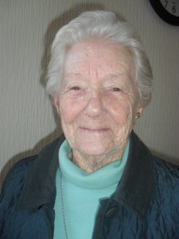](http://bournemouthblindsociety.uk/bbs/wp-content/uploads/2015/02/SDC13643.jpg)*From Jean, “I crossed your threshold enveloped in ‘poor me’ syndrome but with cunning and gentle persuasion you gave me back my zest for life. I now do things I thought were beyond me and daily think how lucky I am that you are always there. Your influence even affects my family and friends whose feelings range from mirth to amazement and frequently disbelief when I tell them of my latest exploit. Thank you for being there for myself, my family and friends – keep up the good work!”*

[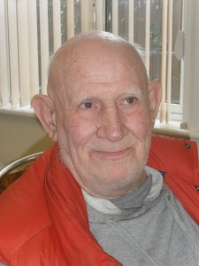](http://bournemouthblindsociety.uk/bbs/wp-content/uploads/2015/02/SDC13639.jpg)

From Alan, *“Losing my sight is still a very raw, emotional subject, I was in despair before I came to Bournemouth Blind Society and was grieving the loss of my eyes but I’ve come such a long way since I started coming here.   There’s not one person here who hasn’t helped me, I am so thankful.”*

Bournemouth Blind Society, 5 Victoria Park Road Bournemouth BH9 2RB tel:01202 546644   
E-mail: [info@bournemouthblindsociety.uk](mailto:info@bournemouthblindsociety.uk) Opening Hours: Monday - Friday 9am - 4.30pm  
Charity No: 1114570 Company No: 5792657

# A word from our Patron, Gaynor Keeble

*“I am delighted and privileged to have been asked to become the Patron of Wessex Chorus.*

*“I first heard them singing when I was adjudicating them in the choir classes at the Bournemouth Festival. They are a choir full of enthusiasm and enjoyment in their singing. Singing in a choir is such an uplifting and fulfilling thing to do and I was very happy to try and help them achieve even better results.*

*“Choral singing was a very large part of my early singing years and through it I gained lifelong friends and many skills which helped me in my singing career.*

*“Being part of a choir is like having a musical family and also allows people to undertake things they would not necessarily be able to do on their own. I am so impressed with the amount of charity work Wessex Chorus does and the money they have raised for worthy causes.*

*“Once again, I am thrilled to begin an association with this choir and look forward to working with them on projects in the future.”*



# Gaynor’s Profile

Gaynor Keeble B.Ed ( Hons) ARAM ARCM ALCM Mezzo Soprano enjoys a varied career. She gained scholarships to Warwick University and Royal Academy of Music. She started her career with Welsh National Opera and has since gone on to sing many roles with most of the national companies including Royal Opera House, English National Opera and Opera North. Roles include Marcellina (Marriage of Figaro), Annina (La Traviata), Witch (Hansel & Gretel), 3rd Lady (Magic Flute), Larina (Eugene Onegin) and Kostelncicka (Jenufa). She is also a highly accomplished oratorio singer, performing with orchestras such as CBSO, BBC Symphony Orchestra & London Mozart Players performing such works as Elijah, Dream of Gerontius, Verdi Requiem, Messiah, Music Makers. She has also performed Gilbert & Sullivan extensively, having worked for D’Oyly Carte, Carl Rosa and the International Gilbert & Sullivan Festival.

In addition to her own singing she takes great joy in helping and encouraging singers of all ages through her own private teaching practice and the University of Warwick. She is also in great demand as an adjudicator for the Federation of Music Festivals and works as vocal consultant for various choirs.

Gaynor Keeble Mezzo Soprano  
07860 904722  
01675 442187  
[gaynor@keeblemezzo.co.uk](mailto:gaynor@keeblemezzo.co.uk)  
[www.gaynor.keeble.co.uk](http://www.gaynor.keeble.co.uk)

*Charity Focus Two*  

Help & Care is a registered charity that supports people and communities to live the lives they choose.

For over 30 years, we’ve been promoting dignity and independence for all people, particularly those in later life, people living with a long-term health condition and carers. What makes us different is our person-centred approach. We understand that each individual has different needs, so we listen and offer a personalised solution, with a “can do” attitude. Based in Bournemouth, we offer services across South-Central England.

**Support Planning & Advocacy Service**

Advocacy can help you to have your say. Our Advocates will meet you one to one to offer the support you need, including providing information and signposting, visiting you at home, or helping you to voice your opinion in meetings and appointments.

**Healthwatch**

Help & Care has a long history of supporting people to have their say on how health and social care services are delivered. Local Healthwatch gives people a powerful voice to influence the delivery and design of their local services.

**Home & Garden Maintenance**

Our social enterprises provide home repairs and gardening maintenance to people who are looking for a reliable, safe, convenient and competitively priced service.

**Information & Signposting**

We provide information and advice to unpaid carers and vulnerable people in the community. Our highly skilled team are trained listeners, taking the time to understand the difficulties faced by the caller before signposting or making a referral for more support, self-help or advocacy.

**Volunteering**

We offer a wide variety of volunteering opportunities for people to support their local community. From volunteering at our charity shop to becoming a telephone befriender. Find what best fits you!

**Health Coaching**

Health Coaching is a service that helps people who live with a long-term health condition to manage the emotional and practical impact of their illness in their day-to-day life.

**Community Development**

We support the development of supportive communities that enable adults of all ages to remain living independent, fulfilling lives as long as possible.

**Can you help us?**

As a charitable organisation, Help & Care relies on the local community. If you wish to support us to change lives and improve communities, there are lots of ways you can help. We always welcome new volunteers, fundraisers, stock for our charity shop or legacies and money donations. To find out more, visit our website or give us a call.

**Contact us**

Find out how we could help you:

Telephone: 0300 111 3303 (Charged at local rate)

Email: [contact@helpandcare.org.uk](mailto:contact@helpandcare.org.uk)

Visit our website: www.helpandcare.org.uk

Or write to us at:   
Help & Care,  
The Pokesdown Centre,   
896 Christchurch Road, Bournemouth BH7 6DL

Help & Care is a Company Limited by Guarantee Registered in England and Wales

Registered Company No. 3187574  
 Registered Charity No. 1055056

*Our Big Gig*

A little historical background…

During the first five years of Wessex Chorus, the historic and variously-named Boscombe Manor – standing dilapidated but at one time purchased and rebuilt as an intended home for Mary Shelley, author of Frankenstein - was undergoing extensive renovation and redevelopment into the thriving Healthcare complex it is today.

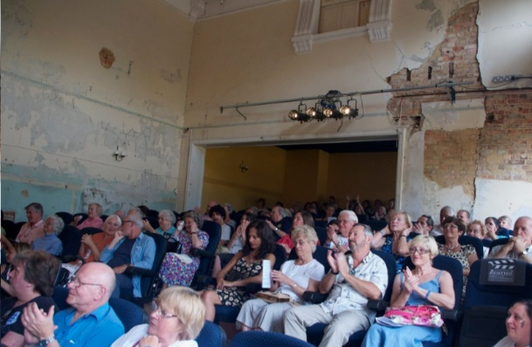It was in fact Mary Shelley’s son, Sir Percy Florence Shelley, 3rd Baronet of [Castle Goring](https://en.wikipedia.org/wiki/Castle_Goring), Sussex, who took up residence there with his wife, Lady Jane, after Mary died in 1851. One of Sir Percy’s interests was in acting and making theatre scenery and he had a substantial theatre built as an extension to their new home.

Lady Jane’s bedroom was adjoining the upper rear wall of the theatre. As she became frail in later years and could no longer descend to the auditorium, she would view performances from her bed, through an open hatch door. In a neat piece of planning, the bedroom is now the theatre’s projection room and projection is through the hatch!

In around 2010, Shelley Theatre (now so called) was, like the house, in a poor condition and awaiting funding for refurbishment.

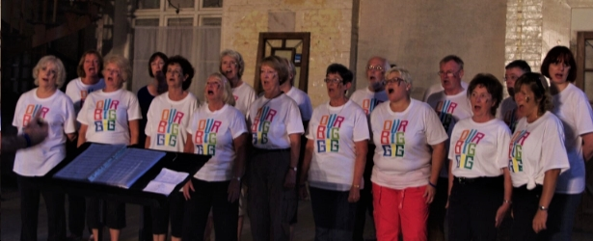Temporarily, all the necessary Health and Safety requirements had apparently been satisfied and Wessex Chorus staged a number of concerts there to help the theatre get started.

On 1st May, 2013, in connection with a nationwide celebration of community music making, we were informed that a new project called Our Big Gig was looking for 275 voluntary event organisers each to host a concert between 11th and 14th July ***of the same year*** with the promise of a grant of £400 for doing so.

Two ideas converged and, with so short a lead-in time, we became very focussed! Could Wessex Chorus hold Our Big Gig at Shelley Theatre? It was a bold gamble but it paid off, handsomely, helped the theatre development move forward and gave Wessex Chorus another leap of confidence into the future!



*Charity Focus Three*

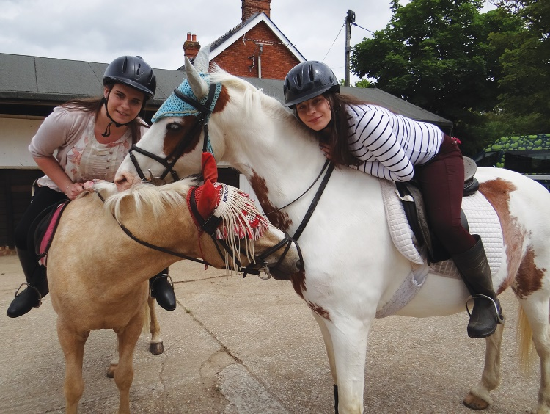Local charity, Youth Cancer Trust, celebrates its 20th Anniversary providing support and free therapeutic activity holidays for teenagers and young adults with cancer (aged 14-30) from the UK and Ireland. Over the past 20 years, Bournemouth’s Tracy Ann House in Alum Chine has welcomed and supported thousands of young cancer patients.



Founder, Brenda Clark, was proud to be awarded the British Empire Medal at the start of the year in the Queen’s New Year’s Honours list in light of her 20 years’ service to young people with cancer.

*“For me the charity has not only allowed me to rebuild the loss of confidence but has enabled me to do so in a safe and homely environment with like-minded peers - that has a support group effect”* Dave

Thank you to Wessex Chorus for supporting Youth Cancer Trust.

[www.youthcancertrust.org](http://www.youthcancertrust.org)

*From the Music Director*

My name is Martin Arthur and I am the founder of Wessex Chorus.

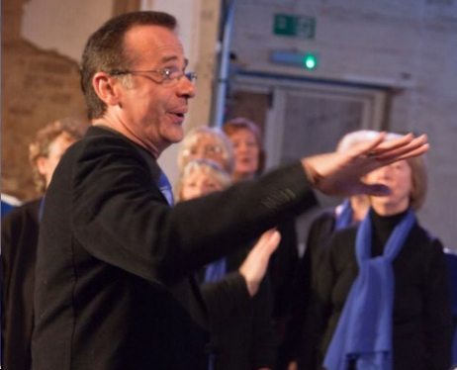My inspiration has always been to prove that we can all sing and be able to be “For The Joy of Giving Through Music”.

It was nearly ten years ago when my life was passing between work, dancing, church music director, and especially my family, and in particular my Mother, who was diagnosed with Alzheimer’s and lived with it for over ten years. I felt at this time how unfair, then rather than making it a negative I decided to turn it positive and bring my dream to fruition and create a community choir for all.

This was before Gareth Malone started his own journey, but with my inner enthusiasm for music, I thought, “Why not?!”

We started small, less than a dozen singers turned up at the first evening rehearsal, at MCC Church Hall, Hannington Road, Pokesdown, Bournemouth at 7:30 pm. Now we are nearly forty full time members, and have nearly sixty singers on our books, Plus, we have gained a full-time accompanist for our performances and one for our rehearsals too. We are spoilt!

We become not only a choir and sing in harmony but a family in unison and, hopefully allowing each member to be themselves, creating great music and making new friends.

My long-time partner Mike thought that I would like a lift so, in 2010 (4 years after our civil partnership), in secret and with my choir, friends and family, he engineered a big surprise for me!

Mike had to use subterfuge to get me to Glasgow and into the studio where the BBC1 programme was recorded. (*see later*)

We have gone from strength to strength singing for charities and audiences big and small, and still we go on, steadily growing in size, love and quality. This year we had our summer concert at the Barrington Theatre and in just one concert we raised not only £1,300 profit for the Bournemouth Blind Society, but also £500 for our choir funds to enable us to sing for local events, and allow us to raise even more for local charities in the future.

The five charities we have supported so far are detailed elsewhere. From just an acorn of an idea to make a difference in people’s lives, came a large oak tree of love, friendship and singing and the touching and changing of many lives.

I truly hope you will be celebrating our 10th Anniversary Year ‘For the Joy of Giving Through Music’ with us.

*It is hard to recognise Martin Arthur that I met 25 years ago.*

*There was big mahogany piano in his flat covered in potted plants. I can recall asking him did he play piano, was he musically inclined?*

*The answer was rather sad, I can play I'm not that good and through bullying at school I don't have a lot of confidence. I asked him to play for me.. Nervously, he lifted the lid and tinkled the tune. I think it was Evergreen. I'm tone deaf so forgive me if wrong tune... or am I?*

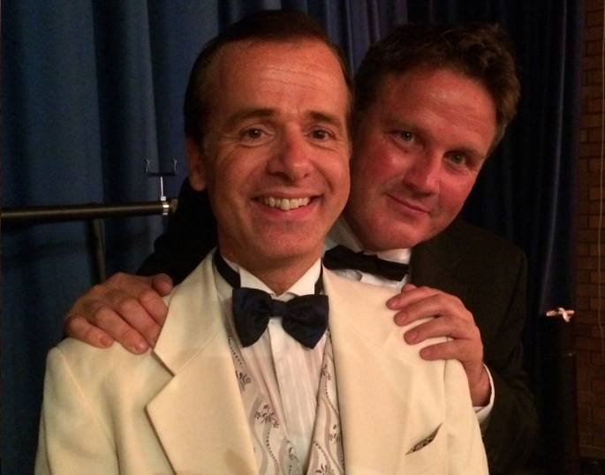*Over the coming years, music through sneaky persuasion became a bigger part, playing for MCC Church and becoming its longest serving Musical Director.*

*Then Martin realised he was not the only one with dormant musical ability, and wanted others to join. Some that had not sung for years, others that were looking for a new musical home. The Wessex Chorus was formed. At the same time, we lost Martin’s mum, Kathleen Arthur, to the Alzheimer's disease.*

*It was then Martin wanted to make a difference and chose the Alzheimer’s Society for the choir to raise funds for.  
  
Such is the warmth and kindness of Martin, he wanted to ensure everybody felt welcomed and developed the philosophy for the joy of giving through joy of singing.*

*His patience and passion for music ensures everyone feels comfortable, and the testament to this is the Wessex Chorus now has over 60 on its books, which is five times greater than the original concept.*

*As we start the Wessex Chorus 10th Anniversary, you may think ‘Do choirs flag after years?’ The answer is No, this one flourishes. It is always looking for new singers and also local Charities to support. Sit back and enjoy our events. Thank you for joining us.*

*Written by Mike Carlile, Partner, Martin’s husband, in memory of Kathleen Amelia Arthur a special Mother-in-law;*

*gentle, kind and much missed.*

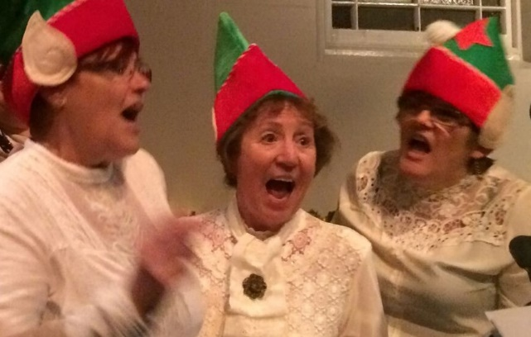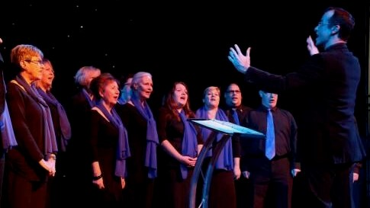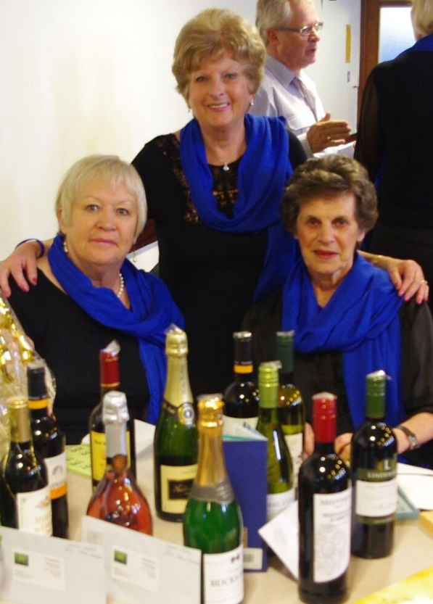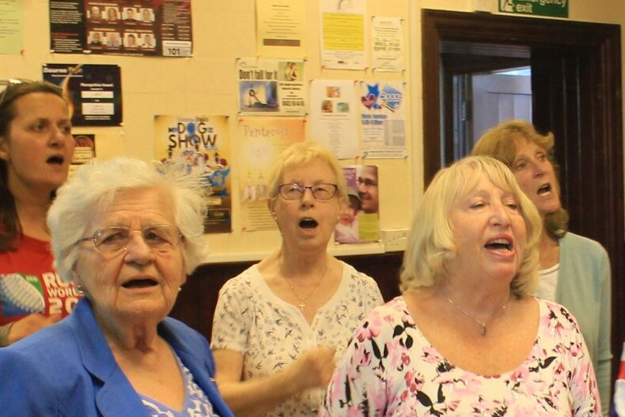*Serious it ain’t*

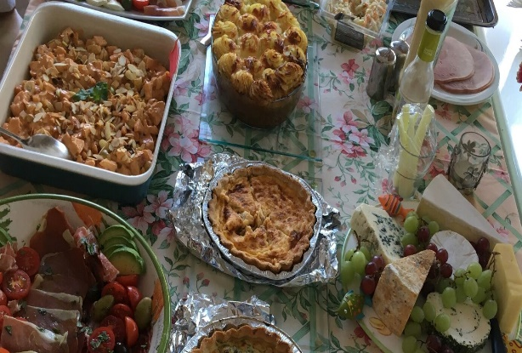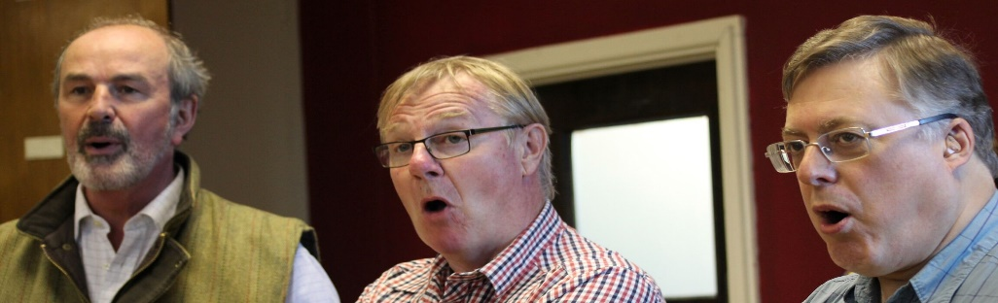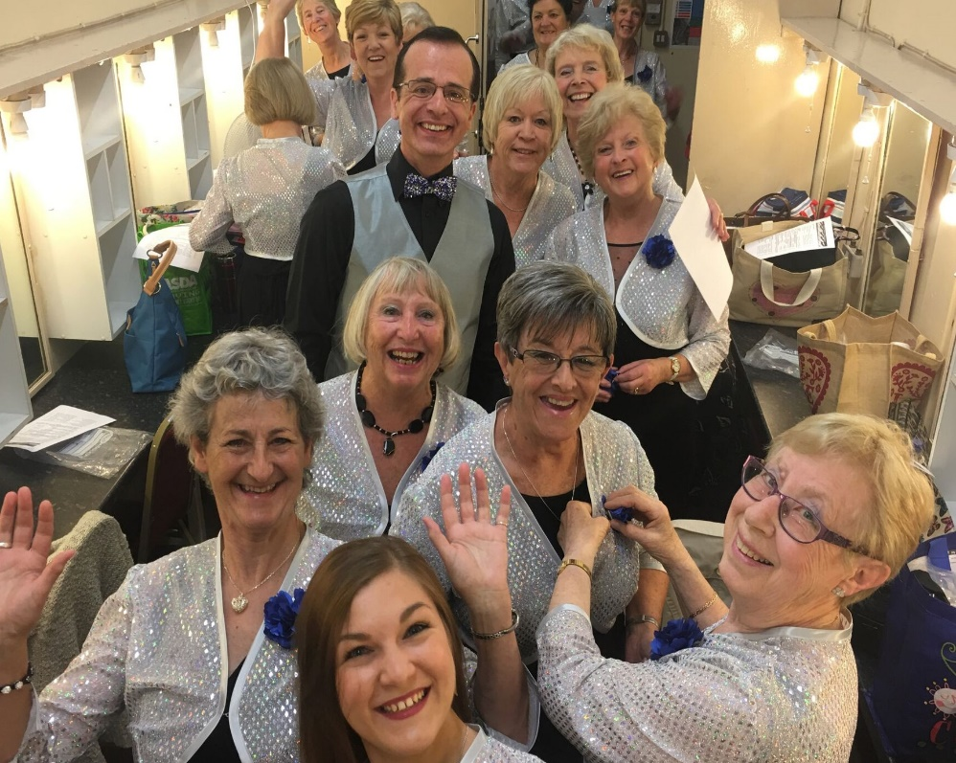



*Charity Focus Four*

We are a very small charity that grants wishes for children with life threatening illnesses across the UK. We support children between the ages of 4 and 17 years of age who are suffering from illnesses such as Brain Tumours, Leukaemia, Cystic Fibrosis, Muscular Dystrophy, organ failure and other degenerative illnesses.

We are very proud to say that we are now in our 28th year and are still going strong. Our goal as a charity has always remained the same; granting handcrafted wishes for as many children as possible, but over the years we, as a charity, have evolved in several ways to better achieve this goal.

Recently we have developed our handcrafted approach by including a small gift for the wish child and their siblings. By providing a gift, their wish becomes real from the moment they receive their wish pack.

Within the last 10 years we have set up an Ambassador Scheme, which we have since developed further. Our Ambassadors now include wish parents, young people and the wider community, meaning that our reach has expanded wider than it ever has been.

Our Board of Trustees has also diversified and now not only includes Round Table family members, but also parents and community partners.

Within the last five years, we have also undergone a complete rebrand and now carry a very befitting dandelion as our logo. Our most recent addition to the team is Dandi Lion, the RTCW lion.

Going forward as a charity, we are now exploring ways in which we can reach a wider range of children with complex illnesses.

*Mike springs a memorable surprise*

One endearing quality in our Music Director’s nature that is most likely one of the secrets of Wessex Chorus’s success is his need to keep everything under control, down to the last detail! Way back in August 2010, when the young Wessex Chorus was only just over fifteen singers strong, the choir became swept up in a plot by Martin’s husband, Mike, to spring a surprise on Martin that involved one of his favourite TV personalities, John Barrowman, who was recording a programme of Tonight’s the Night for the BBC in Glasgow.



In Mike’s words at the time, *“It all started some months ago when I sent a casual email to the programme’s website. I never dreamt they would take up my proposal to put Martin on the Show!”*

With less than one week’s notice, the whole choir dropped what they were doing on the day in question and prepared to be whisked up to Glasgow for a day in the BBC Scotland studios. It was just 8:30am when our excited gaggle of singers and friends stepped off the plane in Glasgow and took a fleet of taxis to the studios.

So much for being in total control, Martin knew nothing of all this! Thinking he was just on a trip to Scotland to watch the Show, he and Mike flew about an hour after the choir and spent a rather less interesting day at BBC Scotland waiting for the show to be presented.

In the Show, John Barrowman was to acknowledge the work Martin had done, in founding Wessex Chorus and raising funds for charity, and dedicate a songto Martin. The plan was for the whole choir to appear on stage as a backing for the song but, first, we needed a morning with a BBC voice coach to learn the song! That was one of the first real challenges for Wessex Chorus and we had no Martin to hold us together! Then came rehearsals, the dress rehearsal and the performance itself.

At lunch time, the choir were shown around BBC Scotland, playing a kind of tag game to dodge Martin and Mike who, we were told, were also circulating in the building at the time! We had been asked to come all dressed in black and, in our tour, we came across a busy seamstress at her sewing machine producing pashminas out of an electric blue coloured fabric. These, together with matching ties for the men, were to become a Wessex Chorus ‘uniform’ for many years to come.

We need to cut a long story short! Suffice to say this was Martin’s reaction to the TV recording, *“I was taken completely by surprise when John Barrowman picked me out in the audience and brought me on to the stage. I was even more dumfounded when the Wessex Chorus emerged from behind a screen to join John Barrowman singing the song ‘You’ve got a friend’. It was their first appearance without me conducting!”*

Job well done, Mike!



*Charity Focus Five*

A huge thank you to Wessex Chorus for choosing to support Alzheimer’s Society.



​Dementia devastates lives. By 2021, one million people will be living with the condition. But dementia won’t win. Until the day we find a cure, Alzheimer’s Society will be here for anyone affected by dementia – wherever they are, whatever they’re going through.  ​

We provide expert information, training, and support services to all those who need our help. And we are creating a more dementia friendly society so people with the condition can live without fear and prejudice.

In Dorset, there are currently over 12,000 people with dementia. Operating from our office in Poundbury, near Dorchester, we deliver the Memory Support and Advisory Service which is designed for anyone with memory loss or diagnosed with dementia and their carers across the whole of Dorset. Our Memory Advisors ensure they get the local support from services they need to allow them to live well with dementia.

Each and every penny raised will make a huge difference to people living with dementia, and their carers.

*What the Choir Means to Me*

In 2011 I met Martin at a dance competition. I was introduced to him a by a dance colleague and Martin became my dance partner and best friend. I knew he ran a choir although had not thought of joining. Then, in 2015, I decided to join Wessex Chorus for the winter, just for the carols, that was all as I did not want the commitment. Well it seems as though I did enjoy it very much and I am still there, very much part of the most wonderful, friendly choir. I feel lucky to be a part of it.   
Thank you, Martin and Wessex Chorus.

Debbie (soprano)

"An added spark to help your day  
You may find Wessex Chorus is the way  
A happy place for you to be  
With camaraderie and a little therapy  
Come join our joyful throng  
Bringing sunshine to your life through song!"

Julie (soprano)

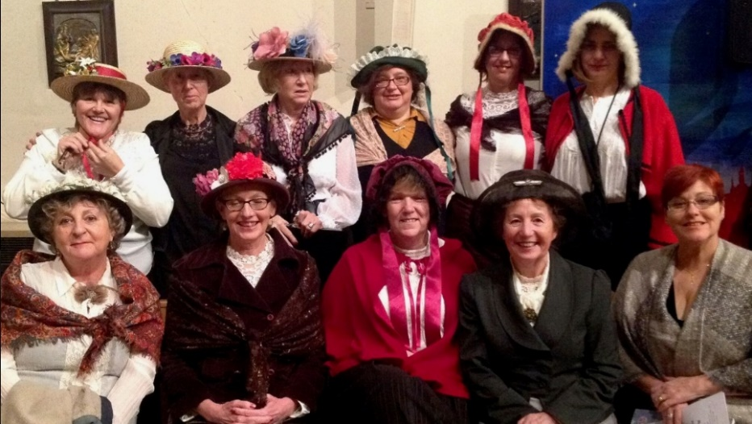I joined the Wessex Chorus about five years ago. Little did I know then, how much the choir would come to mean to me. The people come from all walks of life. I can honestly say the warmth and friendship is part and parcel of who we are. We all have our stories to share or not as we choose. For fear of using a well coined phrase, we really are like one big family. We support and sustain each other with love and buckets full of laughter and all before we even sing a note!

We have an active committee whose work, behind the scenes, helps us to make a real difference to the lives of others. Over our first ten years we have raised thousands of £££s for charities whose work is essential for those in need.

The music is what brought us together, but we have become so much more because of it. We sing ‘for the joy of giving through music’. Our community is right at the centre of what we do, it really defines who we are.

Some of us just like to sing weekly and not at the concerts and that’s fine. Most of us though look forward to singing in front of family, friends and the public which is great fun.

I love concert nights, the rushing around getting myself dressed up, the butterflies in my tummy, the growing excitement waiting for the curtain to go up and finally the music begins. That’s when my inner child is once again is set free!

Lynn (alto)

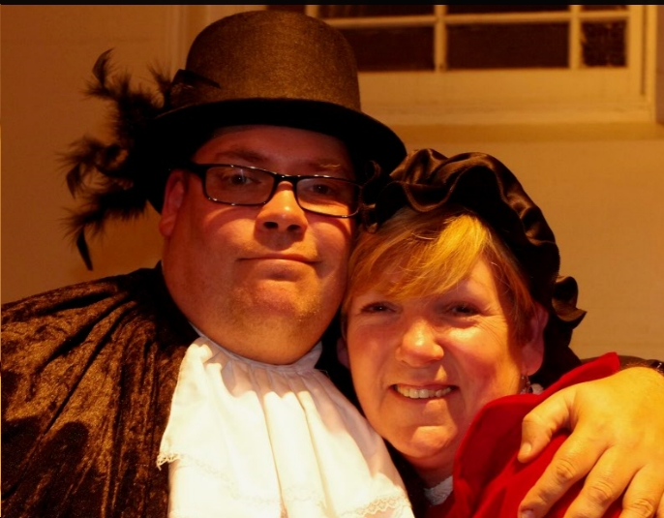When I first joined Wessex Chorus, I had no confidence and only a handful of friends but the choir has changed my life. I now do solos and duets, I have made lots of friends and some I would class as ‘family’. I have had lots of ups and downs but, through bad and sad times, my friends in the choir have been there for me and helped me get through.  
I will always be eternally grateful for their love and support.

Martin (tenor)

I joined nearly 7 years ago wondering how I would cope, not reading music. I need not have worried, as I found many other members were in the same position as myself. I have always loved singing, but never realised how satisfying it is to sing with like-minded people.

Over the years so many friendships have been formed within the choir. There is always a very joyful atmosphere at our rehearsals, brought about in many ways by our music director, Martin Arthur. He is an inspiration to us all, and works so hard to ensure we not only enjoy our singing, but also the social side of being in a community choir.

I was unable to be at rehearsals last year, due to ill health of myself and my husband. During that time so many friends in the choir supported us both, with emails cards phone calls and visits. We both appreciated it so much.

Mimi (soprano)

I joined the choir after the loss of my wife. The sheer pleasure of making music together, combined with the 'choir family' who are so supportive of each and everyone's particular anguishes has been wonderful for me. We all rise above the everyday norms and give strength to one another to keep singing and to be positive.

Tony (bass)



10th Anniversary Year Gala Concert

*Raising funds for five local Charities*

Saturday 4th August 2018 7:30 pm

Hamworthy Club, Magna Road, Canford Magna, Dorset, BH21 3AP

Tickets £20, including Buffet Meal, from choir members

Check wessexchorus.org.uk

********